Swachhta Pakhwada (15/10/2018 to 31/10/2018)
Commissioner, CGST Commissionerate, Ludhiana administered Swachhta Pledge to the officers and staff of CGST Commissionerate, Ludhiana on 15.10.2018 & inaugurated Swachhta Pakhwada. The pledge was also administered to the officers &staff in various GST divisions( GST Commissionerate , Ludhiana) by divisional AC/DC’s.

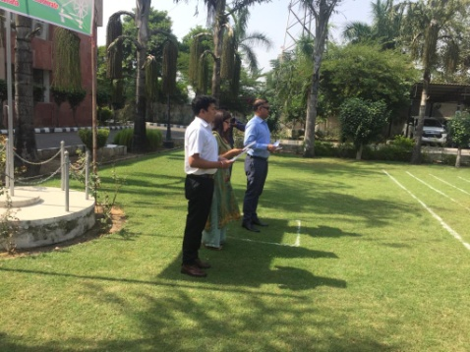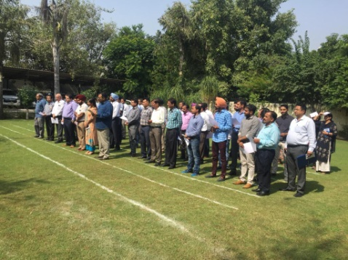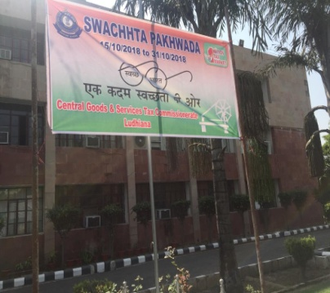

Pictures of Swachhtha Pledge being administered at GST Commissionerate , Ludhiana on 15.10.2018.

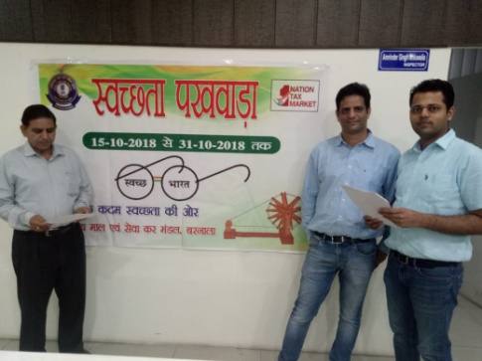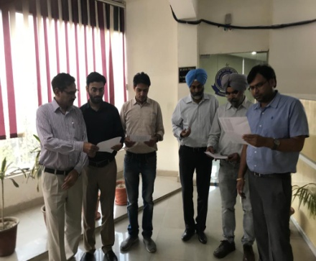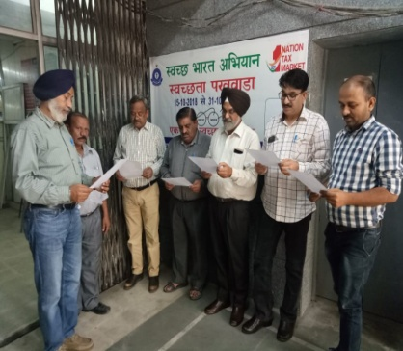
GST Division -Barnala GST Division –Ludhiana(E) GST Division - Ferozepur

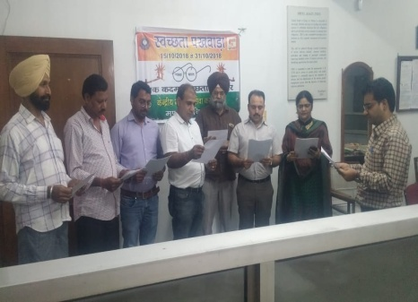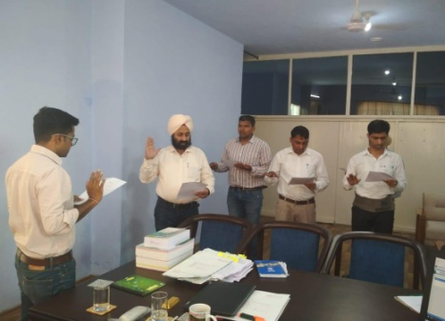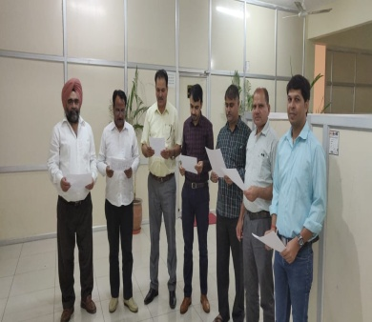

GST Division -Mandigobindgarh GST Division -Sangrur GST Division –Ludhiana(S)

Pictures of Swachhtha Pledge being administered at different Divisions of GST Commissionerate , Ludhiana on 15.10.2018.

